Exercise on data structures in R
- Create a vector v1 containing elements 2,4,6,8,10 then
- Find length of vector
- Find sum of all the elements in the vector
- Find mean
- Add 5 to each element of the vector.
- Accessing and Modifying Elements in Vectors
- Create a vector v2 containing the elements 3, 5, 7, 9, 11. Then:
- Access the 3rd element of the vector.
- Replace the 2nd element of the vector with 15.
- Extract all elements that are greater than 6.

Step 1: Create a Vector
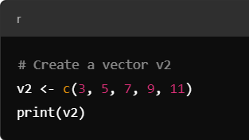
- Here, c() is a function in R used to create a vector by combining its arguments.
- We create a vector v2 that contains the elements: 3, 5, 7, 9, and 11.

Step 2: Access the 3rd Element of the Vector
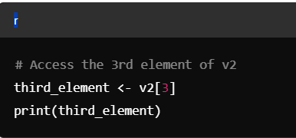
- In R, we can access specific elements of a vector using square brackets [ ] and providing the position (index) of the element we want.
- Here, v2[3] accesses the 3rd element of the vector v2, which is 7. The index starts from 1 in R.

Step 3: Replace the 2nd Element of the Vector with 15
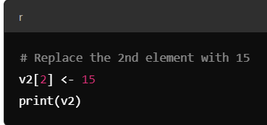
- To modify an element in a vector, we can assign a new value using the same indexing method.
- Here, v2[2] <- 15 replaces the 2nd element (which was previously 5) with 15.
Step 4: Extract All Elements Greater Than 6
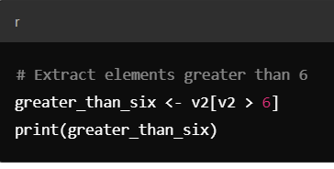
- To filter a vector based on a condition, we can use logical operations. The condition v2 > 6 returns a logical vector that checks each element of v2 to see if it is greater than 6.
- When you use this logical vector inside square brackets v2[v2 > 6], R will return all the elements of v2 where the condition is true.
- The result will be 7, 9, 11, and 15, since these are the elements greater than 6.

Exercise 3: Arithmetic with Vectors
Problem:
Given two vectors v3 = c(1, 2, 3) and v4 = c(4, 5, 6), perform the following operations:
- Add the two vectors element-wise.
- Subtract v4 from v3 element-wise.
- Multiply the two vectors element-wise.

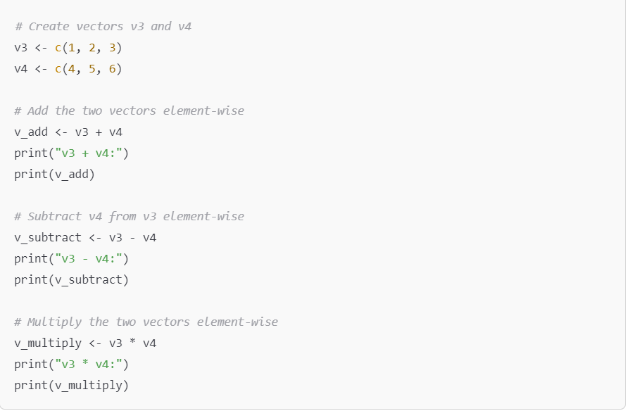

Exercise 4: Dot Product of Vectors
Problem:
Given two vectors v5 = c(2, 3, 4) and v6 = c(5, 6, 7), compute the dot product of the two vectors.
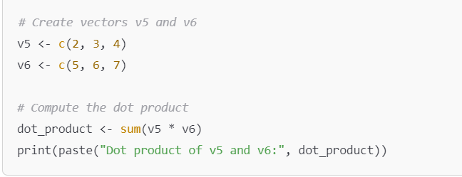

Exercise 5: Filtering Elements in Vectors
Problem:
Create a vector v7 = c(9, 2, 5, 4, 8). Perform the following operations:
- Extract all elements greater than 5.
- Replace all elements less than 5 with 0.

Exercise 5: Filtering Elements in Vectors
Problem:
Create a vector v7 = c(9, 2, 5, 4, 8). Perform the following operations:
- Extract all elements greater than 5.
- Replace all elements less than 5 with 0.
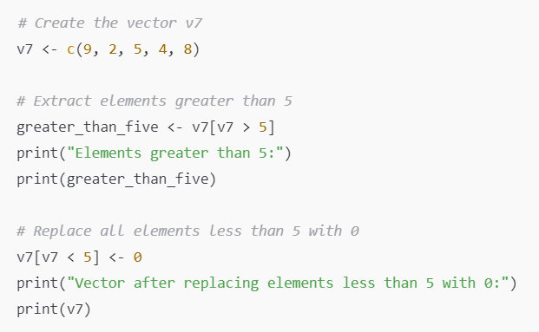

Exercise 6: Vector Repetition and Sequences
Problem:
- Generate a sequence of numbers from 1 to 20 with a step of 2.
- Repeat the vector c(2, 4, 6) three times.
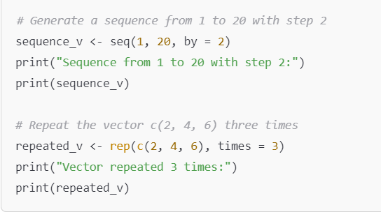

Exercise 7: Vectorized Operations
Problem:
Create a vector v8 = 1:10. Perform the following operations:
- Multiply each element of the vector by 2.
- Take the square root of each element.
- Raise each element to the power of 3.
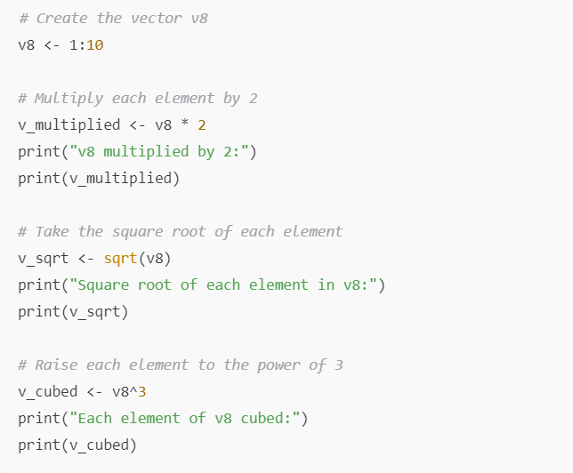

Exercise on List
1. Create a List
Question: Create a list in R that contains the following elements: a numeric vector (1, 2, 3), a character vector ("A", "B", "C"), and a logical vector (TRUE, FALSE, TRUE).
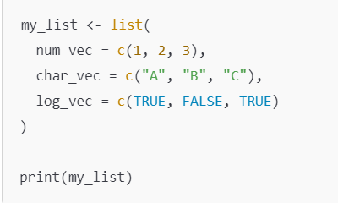

2. Accessing List Elements
Question: Using the list from the previous example (my_list), access and print the second element of the char_vec and the third element of the log_vec.
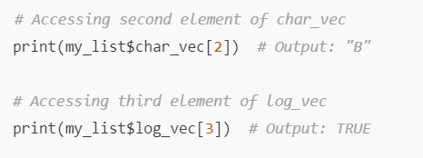

3. Modify List Elements
Question: Modify the first element of the num_vec in my_list from 1 to 10.
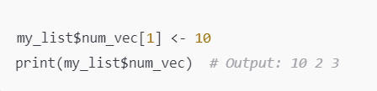

4. Add a New Element to the List
Question: Add a new numeric vector (c(5, 6, 7)) to my_list and call it new_vec.

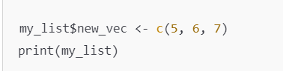

5. Remove an Element from a List
Question: Remove the log_vec from my_list.
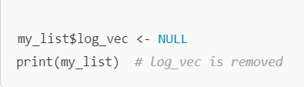

6. Length of a List
Question: Find the number of elements in my_list.
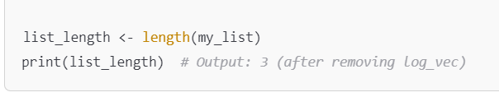

8. Apply a Function to Each Element of a List
Question: Using lapply(), create a list of the squares of each element in the numeric vector c(1, 2, 3, 4, 5).
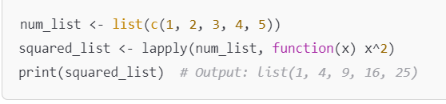

9. Nested Lists
Question: Create a nested list where the first element is a list with a numeric vector (c(1, 2, 3)), and the second element is a list with a character vector (c("A", "B", "C")).
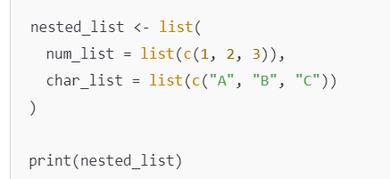

10. Flatten a List
Question: Flatten the following nested list to a single vector:
